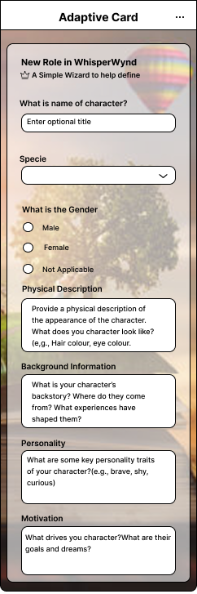CARD 1:

{

"$schema": "http://adaptivecards.io/schemas/adaptive-card.json",

"type": "AdaptiveCard",

"version": "1.5",

"backgroundImage": {

"url": "https://example.com/background-image.png",

"fillMode": "Cover"

},

"body": [

{

"type": "TextBlock",

"text": "New Role in WhisperWynd",

"weight": "Bolder",

"size": "Large"

},

{

"type": "TextBlock",

"text": "⭐ A Simple wizard to help define",

"isSubtle": true,

"wrap": true

},

{

"type": "TextBlock",

"text": "What is name of character?",

"weight": "Bolder",

"wrap": true,

"spacing": "Medium"

},

{

"type": "Input.Text",

"id": "characterName",

"placeholder": "Enter optional title"

},

{

"type": "TextBlock",

"text": "Species",

"weight": "Bolder",

"wrap": true,

"spacing": "Medium"

},

{

"type": "Input.ChoiceSet",

"id": "species",

"style": "compact",

"choices": [

{

"title": "Human",

"value": "human"

},

{

"title": "Elf",

"value": "elf"

},

{

"title": "Orc",

"value": "orc"

}

],

"placeholder": "Select a species"

},

{

"type": "TextBlock",

"text": "What is the Gender",

"weight": "Bolder",

"wrap": true,

"spacing": "Medium"

},

{

"type": "Input.ChoiceSet",

"id": "gender",

"style": "expanded",

"choices": [

{

"title": "Male",

"value": "male"

},

{

"title": "Female",

"value": "female"

},

{

"title": "Not Applicable",

"value": "na"

}

]

},

{

"type": "TextBlock",

"text": "Physical Description",

"weight": "Bolder",

"wrap": true,

"spacing": "Medium"

},

{

"type": "Input.Text",

"id": "physicalDescription",

"isMultiline": true,

"placeholder": "Provide a physical description of the appearance of the character. What does your character look like? (e.g., Hair colour, eye colour)."

},

{

"type": "TextBlock",

"text": "Background Information",

"weight": "Bolder",

"wrap": true,

"spacing": "Medium"

},

{

"type": "Input.Text",

"id": "backgroundInfo",

"isMultiline": true,

"placeholder": "What is your character's backstory? Where do they come from? What experiences have shaped them?"

},

{

"type": "TextBlock",

"text": "Personality",

"weight": "Bolder",

"wrap": true,

"spacing": "Medium"

},

{

"type": "Input.Text",

"id": "personality",

"isMultiline": true,

"placeholder": "What are some key personality traits of your character? (e.g., brave, shy, curious)"

},

{

"type": "TextBlock",

"text": "Motivation",

"weight": "Bolder",

"wrap": true,

"spacing": "Medium"

},

{

"type": "Input.Text",

"id": "motivation",

"isMultiline": true,

"placeholder": "What drives your character? What are their goals and dreams?"

}

],

"actions": [

{

"type": "Action.Submit",

"title": "Submit"

}

]

}

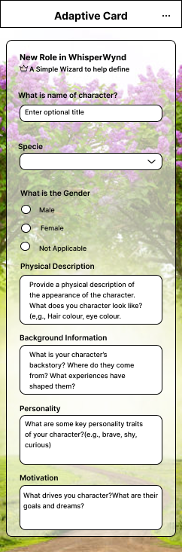CARD 2:

{

"$schema": "http://adaptivecards.io/schemas/adaptive-card.json",

"type": "AdaptiveCard",

"version": "1.5",

"backgroundImage": {

"url": "https://example.com/path-to-your-floral-background.jpg",

"fillMode": "Cover"

},

"body": [

{

"type": "TextBlock",

"text": "New Role in WhisperWynd",

"weight": "Bolder",

"size": "Large"

},

{

"type": "TextBlock",

"text": "⭐ A Simple Wizard to help define",

"isSubtle": true,

"wrap": true

},

{

"type": "TextBlock",

"text": "What is name of character?",

"weight": "Bolder",

"spacing": "Medium",

"wrap": true

},

{

"type": "Input.Text",

"id": "characterName",

"placeholder": "Enter optional title"

},

{

"type": "TextBlock",

"text": "Species",

"weight": "Bolder",

"spacing": "Medium",

"wrap": true

},

{

"type": "Input.ChoiceSet",

"id": "species",

"style": "compact",

"choices": [],

"placeholder": "Select a species"

},

{

"type": "TextBlock",

"text": "What is the Gender",

"weight": "Bolder",

"spacing": "Medium",

"wrap": true

},

{

"type": "Input.ChoiceSet",

"id": "gender",

"style": "expanded",

"choices": [

{

"title": "Male",

"value": "male"

},

{

"title": "Female",

"value": "female"

},

{

"title": "Not Applicable",

"value": "na"

}

]

},

{

"type": "TextBlock",

"text": "Physical Description",

"weight": "Bolder",

"spacing": "Medium",

"wrap": true

},

{

"type": "Input.Text",

"id": "physicalDescription",

"isMultiline": true,

"placeholder": "Provide a physical description of the appearance of the character. What does your character look like? (e.g., Hair colour, eye colour)."

},

{

"type": "TextBlock",

"text": "Background Information",

"weight": "Bolder",

"spacing": "Medium",

"wrap": true

},

{

"type": "Input.Text",

"id": "backgroundInfo",

"isMultiline": true,

"placeholder": "What is your character's backstory? Where do they come from? What experiences have shaped them?"

},

{

"type": "TextBlock",

"text": "Personality",

"weight": "Bolder",

"spacing": "Medium",

"wrap": true

},

{

"type": "Input.Text",

"id": "personality",

"isMultiline": true,

"placeholder": "What are some key personality traits of your character? (e.g., brave, shy, curious)"

},

{

"type": "TextBlock",

"text": "Motivation",

"weight": "Bolder",

"spacing": "Medium",

"wrap": true

},

{

"type": "Input.Text",

"id": "motivation",

"isMultiline": true,

"placeholder": "What drives your character? What are their goals and dreams?"

}

],

"actions": [

{

"type": "Action.Submit",

"title": "Submit"

}

]

}

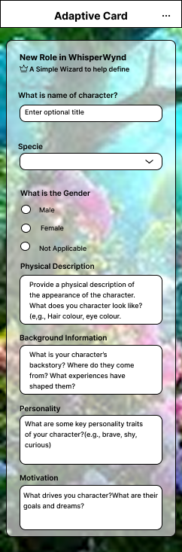{

"$schema": "http://adaptivecards.io/schemas/adaptive-card.json",

"type": "AdaptiveCard",

"version": "1.5",

"backgroundImage": {

"url": "https://example.com/path-to-your-blue-floral-background.jpg",

"fillMode": "Cover"

},

"body": [

{

"type": "TextBlock",

"text": "New Role in WhisperWynd",

"weight": "Bolder",

"size": "Large"

},

{

"type": "TextBlock",

"text": "✨ A Simple Wizard to help define",

"isSubtle": true,

"wrap": true

},

{

"type": "TextBlock",

"text": "What is name of character?",

"weight": "Bolder",

"spacing": "Medium",

"wrap": true

},

{

"type": "Input.Text",

"id": "characterName",

"placeholder": "Enter optional title"

},

{

"type": "TextBlock",

"text": "Species",

"weight": "Bolder",

"spacing": "Medium",

"wrap": true

},

{

"type": "Input.ChoiceSet",

"id": "species",

"style": "compact",

"choices": [],

"placeholder": "Select a species"

},

{

"type": "TextBlock",

"text": "What is the Gender",

"weight": "Bolder",

"spacing": "Medium",

"wrap": true

},

{

"type": "Input.ChoiceSet",

"id": "gender",

"style": "expanded",

"choices": [

{

"title": "Male",

"value": "male"

},

{

"title": "Female",

"value": "female"

},

{

"title": "Not Applicable",

"value": "na"

}

]

},

{

"type": "TextBlock",

"text": "Physical Description",

"weight": "Bolder",

"spacing": "Medium",

"wrap": true

},

{

"type": "Input.Text",

"id": "physicalDescription",

"isMultiline": true,

"placeholder": "Provide a physical description of the appearance of the character. What does your character look like? (e.g., Hair colour, eye colour)."

},

{

"type": "TextBlock",

"text": "Background Information",

"weight": "Bolder",

"spacing": "Medium",

"wrap": true

},

{

"type": "Input.Text",

"id": "backgroundInfo",

"isMultiline": true,

"placeholder": "What is your character's backstory? Where do they come from? What experiences have shaped them?"

},

{

"type": "TextBlock",

"text": "Personality",

"weight": "Bolder",

"spacing": "Medium",

"wrap": true

},

{

"type": "Input.Text",

"id": "personality",

"isMultiline": true,

"placeholder": "What are some key personality traits of your character? (e.g., brave, shy, curious)"

},

{

"type": "TextBlock",

"text": "Motivation",

"weight": "Bolder",

"spacing": "Medium",

"wrap": true

},

{

"type": "Input.Text",

"id": "motivation",

"isMultiline": true,

"placeholder": "What drives your character? What are their goals and dreams?"

}

],

"actions": [

{

"type": "Action.Submit",

"title": "Submit"

}

]

}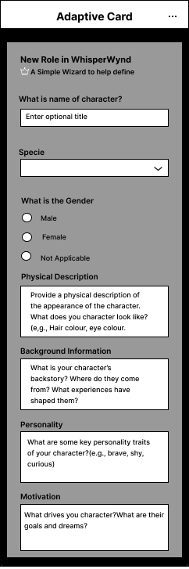{

"$schema": "http://adaptivecards.io/schemas/adaptive-card.json",

"type": "AdaptiveCard",

"version": "1.5",

"backgroundImage": {

"url": "https://example.com/path-to-your-grayscale-background.png",

"fillMode": "Cover"

},

"body": [

{

"type": "TextBlock",

"text": "New Role in WhisperWynd",

"weight": "Bolder",

"size": "Large",

"color": "Light"

},

{

"type": "TextBlock",

"text": "👑 A Simple Wizard to help define",

"isSubtle": true,

"wrap": true,

"color": "Light"

},

{

"type": "TextBlock",

"text": "What is name of character?",

"weight": "Bolder",

"spacing": "Medium",

"wrap": true

},

{

"type": "Input.Text",

"id": "characterName",

"placeholder": "Enter optional title"

},

{

"type": "TextBlock",

"text": "Species",

"weight": "Bolder",

"spacing": "Medium",

"wrap": true

},

{

"type": "Input.ChoiceSet",

"id": "species",

"style": "compact",

"choices": [],

"placeholder": "Select a species"

},

{

"type": "TextBlock",

"text": "What is the Gender",

"weight": "Bolder",

"spacing": "Medium",

"wrap": true

},

{

"type": "Input.ChoiceSet",

"id": "gender",

"style": "expanded",

"choices": [

{ "title": "Male", "value": "male" },

{ "title": "Female", "value": "female" },

{ "title": "Not Applicable", "value": "na" }

]

},

{

"type": "TextBlock",

"text": "Physical Description",

"weight": "Bolder",

"spacing": "Medium",

"wrap": true

},

{

"type": "Input.Text",

"id": "physicalDescription",

"isMultiline": true,

"placeholder": "Provide a physical description of the appearance of the character. What does your character look like? (e.g., Hair colour, eye colour)."

},

{

"type": "TextBlock",

"text": "Background Information",

"weight": "Bolder",

"spacing": "Medium",

"wrap": true

},

{

"type": "Input.Text",

"id": "backgroundInfo",

"isMultiline": true,

"placeholder": "What is your character's backstory? Where do they come from? What experiences have shaped them?"

},

{

"type": "TextBlock",

"text": "Personality",

"weight": "Bolder",

"spacing": "Medium",

"wrap": true

},

{

"type": "Input.Text",

"id": "personality",

"isMultiline": true,

"placeholder": "What are some key personality traits of your character? (e.g., brave, shy, curious)"

},

{

"type": "TextBlock",

"text": "Motivation",

"weight": "Bolder",

"spacing": "Medium",

"wrap": true

},

{

"type": "Input.Text",

"id": "motivation",

"isMultiline": true,

"placeholder": "What drives your character? What are their goals and dreams?"

}

],

"actions": [

{

"type": "Action.Submit",

"title": "Submit"

}

]

}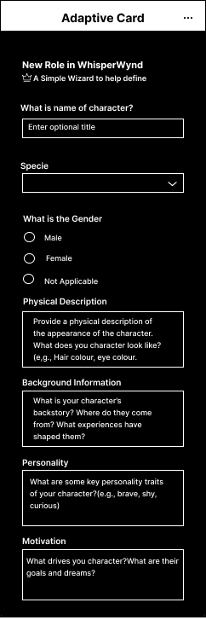{

"$schema": "http://adaptivecards.io/schemas/adaptive-card.json",

"type": "AdaptiveCard",

"version": "1.5",

"body": [

{

"type": "TextBlock",

"text": "New Role in WhisperWynd",

"weight": "Bolder",

"size": "Medium"

},

{

"type": "TextBlock",

"text": "👑 A Simple Wizard to help define",

"isSubtle": true,

"wrap": true

},

{

"type": "Input.Text",

"id": "characterName",

"placeholder": "Enter optional title",

"label": "What is name of character?"

},

{

"type": "Input.ChoiceSet",

"id": "species",

"label": "Specie",

"style": "compact",

"choices": []

},

{

"type": "Input.ChoiceSet",

"id": "gender",

"label": "What is the Gender",

"style": "expanded",

"choices": [

{

"title": "Male",

"value": "male"

},

{

"title": "Female",

"value": "female"

},

{

"title": "Not Applicable",

"value": "na"

}

]

},

{

"type": "Input.Text",

"id": "physicalDescription",

"label": "Physical Description",

"isMultiline": true,

"placeholder": "Provide a physical description of the appearance of the character. What does you character look like? (e.g., Hair colour, eye colour.)"

},

{

"type": "Input.Text",

"id": "backgroundInfo",

"label": "Background Information",

"isMultiline": true,

"placeholder": "What is your character's backstory? Where do they come from? What experiences have shaped them?"

},

{

"type": "Input.Text",

"id": "personalityTraits",

"label": "Personality",

"isMultiline": true,

"placeholder": "What are some key personality traits of your character? (e.g., brave, shy, curious)"

},

{

"type": "Input.Text",

"id": "motivation",

"label": "Motivation",

"isMultiline": true,

"placeholder": "What drives your character? What are their goals and dreams?"

}

]

}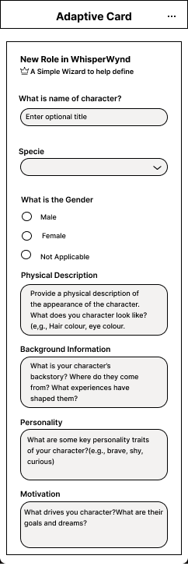{

"$schema": "http://adaptivecards.io/schemas/adaptive-card.json",

"type": "AdaptiveCard",

"version": "1.5",

"body": [

{

"type": "Container",

"items": [

{

"type": "TextBlock",

"text": "New Role in WhisperWynd",

"weight": "Bolder",

"size": "Medium"

},

{

"type": "TextBlock",

"text": "👑 A Simple Wizard to help define",

"spacing": "None",

"isSubtle": true,

"wrap": true

},

{

"type": "Input.Text",

"id": "characterName",

"label": "What is name of character?",

"placeholder": "Enter optional title"

},

{

"type": "Input.ChoiceSet",

"id": "species",

"label": "Specie",

"style": "compact",

"choices": []

},

{

"type": "Input.ChoiceSet",

"id": "gender",

"label": "What is the Gender",

"style": "expanded",

"choices": [

{

"title": "Male",

"value": "male"

},

{

"title": "Female",

"value": "female"

},

{

"title": "Not Applicable",

"value": "na"

}

]

},

{

"type": "Input.Text",

"id": "physicalDescription",

"label": "Physical Description",

"placeholder": "Provide a physical description of the appearance of the character. What does you character look like? (e.g., Hair colour, eye colour.)",

"isMultiline": true

},

{

"type": "Input.Text",

"id": "backgroundInfo",

"label": "Background Information",

"placeholder": "What is your character's backstory? Where do they come from? What experiences have shaped them?",

"isMultiline": true

},

{

"type": "Input.Text",

"id": "personalityTraits",

"label": "Personality",

"placeholder": "What are some key personality traits of your character? (e.g., brave, shy, curious)",

"isMultiline": true

},

{

"type": "Input.Text",

"id": "motivation",

"label": "Motivation",

"placeholder": "What drives your character? What are their goals and dreams?",

"isMultiline": true

}

],

"style": "default",

"bleed": false

}

] }